String Variable

Definition:
# Source: AI Source: Provided by: [Data Path: Persons Table -> ID Column: 1, Name_En Column: Motasem Essam] -> From: [ChatGPT] on [1/26/2026]
A string variable is a named storage location in memory that can hold a string value, allowing the program to store, modify, or manipulate text data during execution.

Key Points
# Source: AI Source: Provided by: [Data Path: Persons Table -> ID Column: 1, Name_En Column: Motasem Essam] -> From: [ChatGPT] on [1/26/2026]
- A string variable can store string literals or user input.
- Unlike a string literal, its value can usually be changed.
- In memory, it is typically an array of characters (C/C++) or an object (Python, Java).

Examples
# Source: AI Source: Provided by: [Data Path: Persons Table -> ID Column: 1, Name_En Column: Motasem Essam] -> From: [ChatGPT] on [1/26/2026]
1. Python
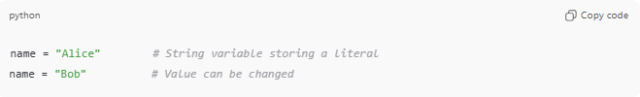
name = "Alice" # String variable storing a literal
name = "Bob" # Value can be changed
2. C
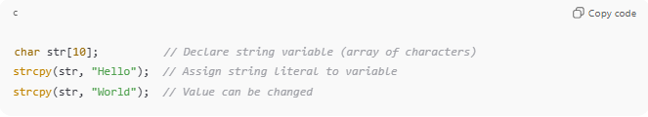
char str[10]; // Declare string variable (array of characters)
strcpy(str, "Hello"); // Assign string literal to variable
strcpy(str, "World"); // Value can be changed
3. Java
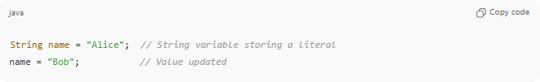
String name = "Alice"; // String variable storing a literal
name = "Bob"; // Value updated

Difference Between String Variable and String Literal
# Source: AI Source: Provided by: [Data Path: Persons Table -> ID Column: 1, Name_En Column: Motasem Essam] -> From: [ChatGPT] on [1/26/2026]
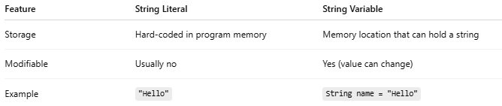
Feature | String Literal | String Variable
Storage | Hard-coded in program memory | Memory location that can hold a string
Modifiable | Usually no | Yes (value can change)
Example | "Hello" | String name = "Hello"

Analogy
# Source: AI Source: Provided by: [Data Path: Persons Table -> ID Column: 1, Name_En Column: Motasem Essam] -> From: [ChatGPT] on [1/26/2026]
- String literal → A sticky note with fixed text
- String variable → A blank board where you can write, erase, and rewrite text

✅ Summary
# Source: AI Source: Provided by: [Data Path: Persons Table -> ID Column: 1, Name_En Column: Motasem Essam] -> From: [ChatGPT] on [1/26/2026]
- String variable = memory storage for a string
- Can store, update, and manipulate string values
- Can hold string literals or dynamically generated strings

